Mobile phone policy
Sherborne Qatar Prep School
Last reviewed on: | 4/8/24
Next review due by: | August 2025

Contents 1
1. Introduction and aims 2
2. Relevant guidance 2
3. Roles and responsibilities 2
4. Use of mobile phones by staff 2
5. Use of mobile phones by pupils 3
6. Use of mobile phones by parents/carers, volunteers and visitors 4
7. Loss, theft or damage 5
8. Monitoring and review 5
9. Appendix 1: 6
11. Appendix 2: Template mobile phone information slip for visitors 7

1. Introduction and aims
At Sherborne Qatar Prep School we recognise that mobile phones and similar devices, including smartphones, are an important part of everyday life for our pupils, parents/carers and staff, as well as the wider school community.
Our policy aims to:
- Promote safe and responsible phone use
- Set clear guidelines for the use of mobile phones for pupils, staff, parents/carers, visitors and volunteers
- Support the school’s other policies, especially those related to child protection and behaviour

This policy also aims to address some of the challenges posed by mobile phones in school, such as:
- Risks to child protection
- Data protection issues
- Potential for lesson disruption
- Risk of theft, loss, or damage
- Appropriate use of technology in the classroom
Note: throughout this policy, ‘mobile phones’ refers to mobile phones and similar devices.

2. Relevant guidance
This policy meets the requirements of the Department for Education’s non-statutory mobile phone guidance and behaviour guidance. Further guidance that should be considered alongside this policy is Keeping Children Safe in Education.

3. Roles and responsibilities
3.1 Staff
All staff (including teachers, support staff and supply staff) are responsible for consistently enforcing this policy.
Volunteers, or anyone else otherwise engaged by the school, must alert a member of staff if they witness, or are aware of, a breach of this policy.
The Headteacher is responsible for monitoring the policy every year, reviewing it, and holding staff and pupils accountable for its implementation.
Staff will address any questions or concerns from parents/carers quickly, and clearly communicate the reasons for prohibiting the use of mobile phones.

4. Use of mobile phones by staff
4.1 Personal mobile phones
As suggested in DFE’s non-statutory mobile phone guidance, Staff (including volunteers, contractors and anyone else otherwise engaged by the school) are not permitted to use their personal mobile phone during teaching time or when on duty. Use of personal mobile phones must be restricted to non-contact time, and to areas of the school where pupils are not present (such as the staffroom).
There may be circumstances in which it is appropriate for a member of staff to have use of their phone during contact time for personal reasons. For instance (this list is non-exhaustive):
- For emergency contact by their child, or their child’s school
- In the case of acutely ill dependents or family members
The headteacher will decide on a case-by-basis whether to allow for special arrangements and staff should inform their line manager if there is a circumstance requiring this.
If special arrangements are not deemed necessary, school staff can use the school office number as a point of emergency contact.
4.2 Data protection
Staff must not use their personal mobile phones to process personal data, or any other confidential school information, including entering such data into generative artificial intelligence (AI) tools such as chatbots (e.g. ChatGPT and Google Bard).
4.3 Safeguarding
Staff should avoid giving their personal contact details to parents/carers where possible and never to pupils, including connecting through social media and messaging apps.
Staff should avoid publicising their contact details on any social media platform or website, to avoid unwanted contact by parents/carers or pupils.
Staff may use their personal phones to take photos of pupils and their work but these must be uploaded to Itrack or Class Dojo and then immediately deleted from the device. Staff should always delete photos from personal devices before the end of each school day.
4.4 Using personal mobiles for work purposes
In some circumstances, it may be appropriate for staff to use personal mobile phones for work. Such circumstances may include, but aren’t limited to:
- To issue homework, rewards or sanctions
- To use multi-factor authentication
- Emergency evacuations
- Supervising off-site trips
- Supervising residential visits
In these circumstances, staff will:
- Use their mobile phones in an appropriate and professional manner, in line with our staff code of conduct
- Not store photographs or recordings of pupils, their work, or anything else which could identify a pupil
- Refrain from using their phones to contact parents/carers wherever possible. In normal corcumstances and during the school day, contact must be made via the school office
4.5 Sanctions
Staff that fail to adhere to this policy may face disciplinary action.

5. Use of mobile phones by pupils
Pupils should not bring phones to school. Where parents decide that their child needs a phone for transport to and from school, they must sign a Mobile Phone Consent Form and the child must hand the phone in at the start of each day, collecting it at home time. They may not use the phone during the school day or while on the premises without a member of staff’s permission.
5.1 Use of smartwatches by pupils
The DfE’s non-statutory mobile phone guidance includes in the term ‘mobile phones’ all devices with communications and smart technology that the school chooses to include in their policy.
Smartwatches are wristwatches with smart technology in them. They can be used to tell the time, send and receive text and voice messages, make calls and listen to music. Some smart watches have wellness and health-related features.
Smart watches should not be worn to school. Where these are worn for the normal purpose of telling the time, pupils must not use them to communicate or take photos, recordings.
5.3 Sanctions
If a phone is used in school and there is no parent consent form, the phone will be confiscated and parents informed to collect from the office at the end of the school day. If a phone has a consent form but the child does not hand the phone in and uses it in school, the parents will be contacted ofr further discussion.
Staff may search a pupil\s phone if there is a reason to believe it holds pornographic images, or photos/recordings have been taken without consent. Parents will be contacted.
- The pupil’s behaviour may indicate they may be suffering, or at risk of, harm. If this is suspected, staff will follow the appropriate procedure set out in Part 1 of Keeping Children Safe in Education
Certain types of conduct, bullying or harassment can be classified as criminal conduct. The school takes such conduct extremely seriously and will involve the police or other agencies as appropriate.
Such conduct includes, but is not limited to:
- Sexting (consensual and non-consensual sharing nude or semi-nude images or videos)
- Upskirting
- Threats of violence or assault
- Abusive calls, emails, social media posts or texts directed at someone on the basis of someone’s ethnicity, religious beliefs or sexual orientation

6. Use of mobile phones by parents/carers, volunteers and visitors
Parents/carers, visitors and volunteers (including governors and contractors) must adhere to this policy as it relates to staff if they are on the school site during the school day.
This means:
- Not taking pictures or recordings of pupils, unless it is at a public event (such as a school fair), or of their own child
- Using any photographs or recordings for personal use only, and not posting on social media without consent
- Not using phones in lessons, or when working with pupils
Parents/carers, visitors and volunteers will be informed of the rules for mobile phone use when they sign in at reception or attend a public event at school.
Parents/carers or volunteers supervising school trips or residential visits must not:
- Use their phone to make contact with other parents/carers
- Take photos or recordings of pupils, their work, or anything else which could identify a pupil
Parents/carers or volunteers supervising trips are also responsible for enforcing the school’s policy for pupils using their phones, as set out in section 5 above, but must refer any sanctions to a member of staff, as they do not have the power to search or confiscate devices.
Parents/carers must use the school office as the first point of contact if they need to get in touch with their child during the school day. They must not try to contact their child on their personal mobile during the school day.

7. Loss, theft or damage
Pupils bringing mobile phones (with prior agreement and parent consent) to school must ensure that the phones are named and kept with the form teacher during the day.
Pupils must secure their mobile phones as much as possible, including using passwords or pin codes to protect access to the phone’s functions. Staff must also secure their personal phones. Failure by staff to do so could result in data breaches.
The school accepts no responsibility for mobile phones that are lost, damaged or stolen on school premises or transport, during school visits or trips, or while pupils are travelling to and from school.
Confiscated phones will be stored in the school office until collected by a parent. If not collected by the end of the school day, the phone will be kept in the school safe within the finance office until it has been collected by a parent.
Any phones found should be taken to the school office. The school will then attempt to contact the owner.

8. Monitoring and review
The school is committed to ensuring that this policy has a positive impact of pupils’ education, behaviour and welfare. When reviewing the policy, the school will take into account:
- Feedback from parents/carers and pupils
- Feedback from staff
- Records of behaviour and safeguarding incidents
- Relevant advice from the Department for Education, the local authority and any other relevant organisations

9. Appendix 1:
Permission form allowing a pupil to bring a phone to school
The school has agreed to allow [pupil name] to bring [their] mobile phone to school because they:
- Travel to and from school alone
- Are a young carer
- Need the phone to support their medical needs
- Are attending a school trip or residential where use of mobile phones will be allowed
- Attend a before- or after-school activity where a mobile phone is required for the activity, or to contact parents/carers
Pupils who bring a mobile phone to school must abide by the school’s policy on the use of mobile phones
The school reserves the right revoke permission if a pupil does not abide by the policy.

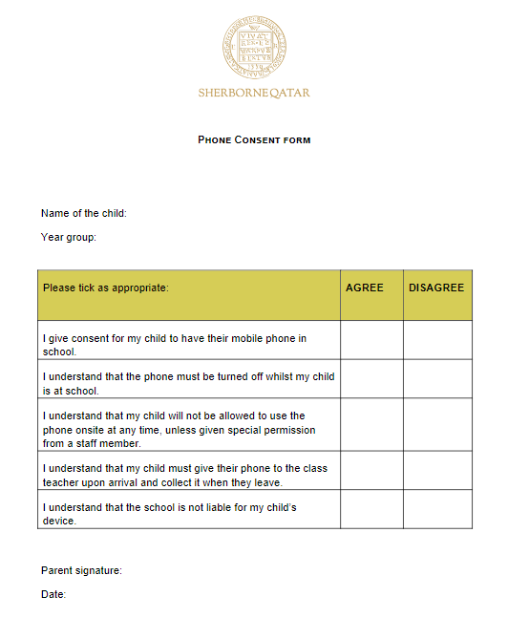

For school use only
Authorised by:
Date:

11. Appendix 2: Template mobile phone information slip for visitors

Use of mobile phones and similar devices in our school
- Please keep your mobile phone on silent/vibrate while on the school grounds
- Please do not use phones where pupils are present. If you must use your phone, you may go to the school office
- Do not take photos or recordings of pupils (unless it is your own child), or staff
- Do not use your phone in lessons, or when working with pupils
The school accepts no responsibility for phones that are lost, damaged or stolen while you are on the school grounds.
A full copy of our mobile phone policy is available from the school office.

