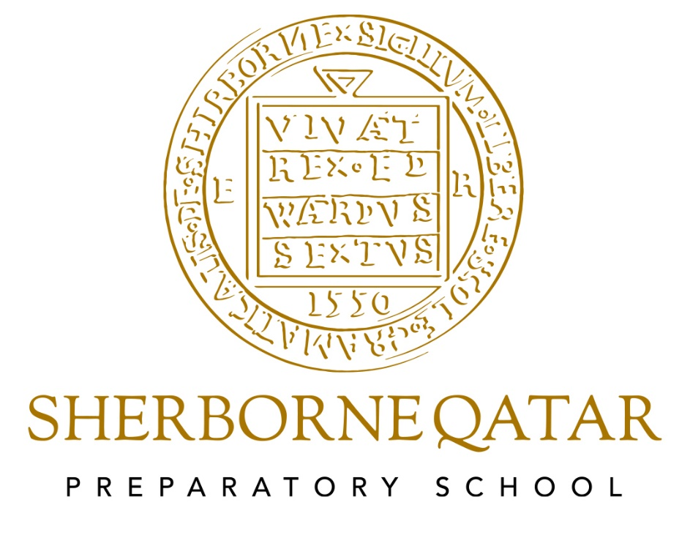
Maths Policy

Last Updated June 24
Next review June 25
Reviewed by Heidi Berry, Headteacher
Maths

Maths is taught every day as a discrete subject. Maths follows the White Rose long term plan guidance on topics taught at different stages in the year. The Mastery approach ensures that the pace of teaching is dictated by the pace of learning. Those who have grasped a skill are challenged to apply their understanding in greater depth whilst others get more focused teacher time. All concepts are introduced through the CPA (concrete, pictorial and abstract) model to ensure concepts are tangible for children.
Why Do We Teach Maths?

Mathematics teaches children how to make sense of the world around them by developing the necessary skills to calculate, reason, communicate and problem solve using mathematical language equipping them to apply this knowledge in a whole host of situations. Children should also be taught to understand and the appreciate relationships and pattern in both number and space in their everyday lives including through art and nature. Through their growing knowledge and understanding, children learn to appreciate the contribution made by many cultures to the development and application of mathematics that we use today.

Our Aims and Objectives

- To promote enjoyment and enthusiasm for learning through practical activity, exploration, investigations and discussion;
- To promote confidence and competence with numbers and the number system;
- To develop a range of computational skills and the understanding behind these methods;
- To encourage a curiosity and fascination in mathematical concepts;
- To develop the ability to solve problems through decision-making and reasoning in a range of contexts;
- To develop a practical understanding of the ways in which information is gathered and presented;
- To explore features of shape and space, develop measuring skills in a range of contexts;
- To understand the importance of mathematics in everyday life;
- To have high expectations of each pupil in terms of their mathematical ability;
- To support and meet the individual needs of each child;
- To meet the requirements of the Foundation Stage Curriculum guidelines and the 2014 National Curriculum guidelines for KS1 and KS2.

How We Teach and Our Children Learn

Expectation of all teachers:
- Planning covers all Maths objectives throughout the year and this will be tracked using iTrack
- A4 Maths books are used for recording
- A high level of presentation is expected with a short date and LO/WALT
- Learning Objectives and Small Steps are displayed in all lessons and are evident in books
- White Rose Maths Long Term Plans are used to create a termly medium term plan
We use a variety of teaching and learning styles in mathematics lessons. These take into consideration the different learning styles of the children and use the White Rose Maths (WRM) approach. Children should be offered a wide range of materials to support their learning and reinforce concepts including; physical objects such as Base 10 and cubes, Numicon, number fans, place value cards, number lines, hundred squares, white boards, coins and other physical objects to aid learning. A Concrete, Pictorial, Abstract (CPA) approach is used throughout the school. Children should be encouraged to communicate their reasoning in a range of settings e.g. whole class, group work or with a partner. Children will be challenged to a variety of mathematical concepts; from the quick fire rapid recall of mental facts specific to their year group to multi-step word problems, calculations or investigations. Where possible teachers and children should use ICT to model and reinforce concepts that have been taught, including starters, main lessons and plenaries.

Sherborne also has a Calculation Policy, which enables teachers to follow guidelines when teaching progression and topics in Maths. However, it must be understood that methods of finding answers vary and this must be accounted for with such a diverse student cohort.

Mastery

In keeping with the National Curriculum 2014, children are encouraged to master topics in Maths, including number, fractions, shape, measurements etc. Mastery is taught via probing questioning and by using White Rose mastery documents, as well as National Centre for Excellence in the Teaching of Mathematics (NCETM) ideas, Third Space Learning, Deeper Understanding and NRICH – documents for each can be found on the shared drive for teachers.

Time Allocation

The time allocated to Maths is 45 minutes – 1 hour a day. In addition to this, Maths should be incorporated into incidental learning opportunities such as telling the time, comparative language and real life problem solving.

Maths Curriculum Planning

In planning Maths, the National Curriculum 2014 Maths Framework is used in Years 1 – 6. Teachers predominantly use White Rose Maths resources to make sure all lessons are matched to the appropriate learning objective. WRM end of block assessments are used at the end of each topic and the summative WRM assessments are completed three times a year during whole school assessment week.

Our planning of Maths provides a framework for the long, medium and weekly term planning, which provides a balance and distribution of topics throughout the year. The WRM LTPs are used as a recommended guide however they are adapted depending on term length and cohort needs. It is the responsibility of the class teacher to adapt the weekly plans accordingly to ensure the needs of the children in their group are met. Many teachers complement this scheme of work with additional material and other ICT tools whilst keeping within the long term and medium term plan.

The Foundation Stage

The Reception teachers incorporate WRM as a method of outlining the long term planning structure for teaching Mathematics, which tie into the learning objectives of the Early Year Goals in Mathematics, namely Numbers, Shape and Space and Measure. Each area has statements which the children are asked to demonstrate, with a level of independence in Mathematics activities and games within the classroom. Maths is incorporated into the continuous provision within the class, used within the children’s play and regular opportunities are found for incidental learning.

The Contribution of Mathematics to Teaching in Other Curriculum Areas

- English: speaking and listening; communicating methods and strategies; reading word problems;
- PSHE: to have the necessary skills to tackle logic and reasoning problems; to learn a methodical approach, patience and resilience;
- Science: data collection, interpretation, associated calculations e.g. using forces;
- Geography: analysing data (e.g. comparing temperature, populations, heights of mountains, area of land mass etc.);
- History: Calculating lengths of eras and periods in history; developing a sense of time;
- Art/Design: recognising symmetry in art and nature (The Golden Ratio); appropriate calculations for design a model; understanding scale and ratio.
Mathematics and ICT

ICT is used to:
- Demonstrate concepts more fully;
- To provide a fun opportunity for pupils to engage;
- To appeal to different learning styles;
- To enable pupil participation;
- Record findings;
- Produce data by way of charts and graphs;
- Typical ICT used is TTRS, Kahoot, Education City and TopMarks.
Inclusion (including GREAT)
We teach mathematics to all children, whatever their ability or individual needs; we provide learning opportunities that enable all pupils to make good progress and gain fulfilment. If a child’s progress falls significantly outside the expected range, the child may have special educational needs. Our assessment process looks at a range of factors – equipment, teaching style, differentiation – so that we can take some additional or different action to enable the child to learn more. Records of children who fall outside of the expected range are held by the SENDCO. Quality First teaching captures most of the class needs with Wave 2 being activated when needs are recognised. Children identified as requiring additional support are moved onto Wave 3 support which includes one-one sessions with a designated adult.

Parent Workshops

Each parent is invited to yearly parent workshops, which demonstrate how their child is taught, the resources used, methods explained and the best way to support children to home.

Assessment, Record Keeping and Target Setting

Children in EYFS are assessed based against the statements held within the Early Year Goals in Mathematics. Whilst there is no formal assessment for children, they are observed by the teacher and photographic evidence is collected on iTrack. As a general rule the teacher aims to observe a child independently demonstrating ‘statement’ skills three times before declaring the child ‘secure’.

In Year 1 – 6, end of block assessments are used as an informal summative assessment throughout the term. TTRS is used to obtain a baseline for times table ability and assessed through the regular application at home and school. Formal tests (White Rose Maths) are administered termly from Years 1 to 6 in Autumn, Spring and Summer and are used to support teacher assessment. All formal test scores and Termly Teacher Assessment scores, for years 1 to 6 are also held on iTrack for each Year group, which allows teachers and SLT to monitor and assess the development in Mathematics on a per child, per class and per year group basis.

Teacher assessment is also used throughout the year to determine age related expectations and are reported to parents (both formal assessments and teacher’s assessment are highlighted, and the reasons for any differences). This information is added to the learning grids in the front of Maths Books. One tick means a child has achieved the LO once, two ticks twice and then highlighted in pink (per marking policy) to indicate they have fully met the target. Class teachers should use these assessments to inform future planning and target setting and are then filed for reference.

Resources

In Pre School each class has a wide range of class resources, including Numicon, number lines, multi-link bricks, number fans, 100 squares, counting bears, rulers, counting sticks and access to Primary Resources Games on their IWB. The aim is to make Mathematics in Pre School as kinaesthetic as possible. As year groups we also share equipment, including coins, balance scales, 2D and 3D shapes, timers, dice and number games.
Each class has hundred squares, Numicon, number lines, a supply of physical equipment as appropriate, white boards, number fans. Other shared equipment is kept in trays and trolleys in areas accessible to all teachers.

All classrooms have a checklist of what they should have available for children to access. In KS1, resource baskets are used in every lesson. In KS2, an independent Maths area is accessible for the children to select what they require. In terms of ICT, each year group has access to iPads and laptops which enable a Maths class to have access to these 1 or 2 times a week.

Health and Safety

When conducting any practical mathematical activity which falls outside of the usual precautions taking during in-class teaching, teachers should make their students aware of any potential hazards.

Extra-Curricular Activities

There are currently ad hoc opportunities for children to develop problem solving skills through extra-curricular activities. There are also House events that include TTRS competitions and STEM days.

Monitoring and Review

The co-ordination and planning of the mathematics curriculum is the responsibility of SLT in conjunction with Heads of Year and class teachers. Assessments are evaluated and targets set at PPMs each term. Whole school data capture for Maths is collated annually.

The Calculation Policy can be found as a separate document

