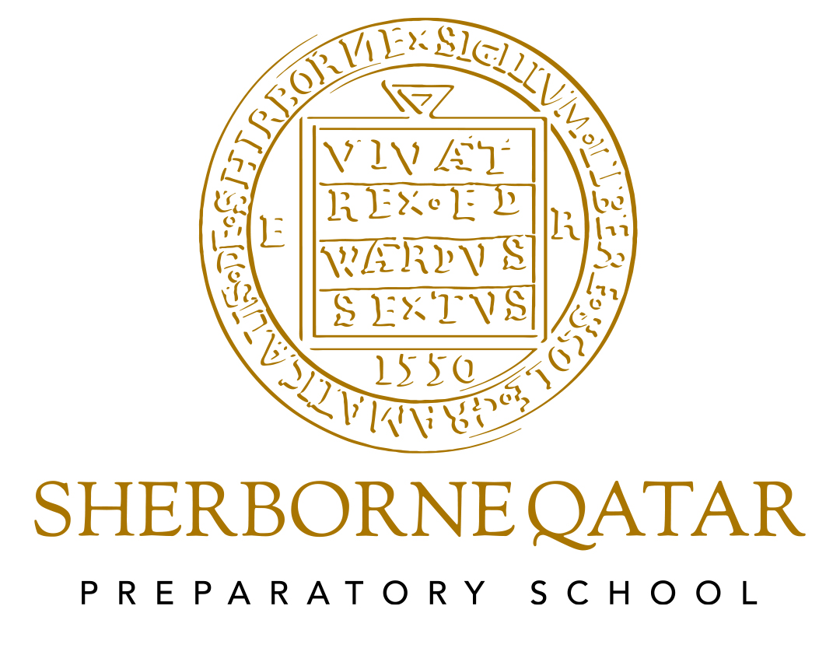

Arabic Policy

Arabic Policy

Last updated June 2024

Next review September 2025

Reviewed by Suzan Saada (Head of Arabic Prep School)

Introduction –Why do we teach Arabic language?
Arabic is the official language in the state of Qatar; therefore, it is of the upmost importance to nurture our youth in it. We aim to meet the educational needs of Arabic pupils, develop their personality and consolidate their sense of national loyalty. The teaching of Arabic as a native language to Qatari pupils is also compulsory under Ministry of Education (MOE) regulations.

Our aims and objectives:

- Use standard Arabic "FusHaa" appropriately in the four key stands (reading, writing, listening and speaking).
- Understand Arabic syntax and to know its functional uses.
- Develop speaking and listening skills according to the situation and recipient, which will enable pupils to interact with local community.
- Use Arabic language to develop research skills.
- Respect national, local, regional, human, religious values.
- Appreciate and understand the importance of "FusHaa" in Arabic and Islamic culture.

How we teach and our children learn
We use a variety of teaching and learning styles in Arabic lessons. Our principal aim and activity focus are to develop the pupil’s skills in word and sentence level, reading, speaking, and listening. We use modern teaching solutions in order to adapt to different learning styles for our diverse set of pupils. The role of ICT has been largely incorporated in our teaching style in order to develop a continuous learning program at school and from home. We encourage pupils to work as a group and individually depending on target skills.

Time Allocation
In the Prep school, pupils of Arabic as a native language have four Arabic lessons per week (240 minutes per week).
Pupils of Arabic as an additional language (non – Arabic speakers) have two lessons a week (90 minutes per week).

Arabic curriculum planning

We use the Ministry of Education (MOE) regulations curriculum. In addition, we have supporting materials. We set up and designed our curriculum for non-Arabic speakers from a variety of resources in the absence of a specific scheme for Primary aged pupils.

A yearly overview is supported by plans for each unit, which contain the yearly plan, weekly lesson plans and learning objectives, as they are adapted and developed as required to meet the needs of each class.

The Foundation Stage

EYFS pupils in reception are taught Arabic 2 times a week (60 minutes). They are taught Arabic together, regardless of whether they are native speakers or not. Pupils split into separate classes from Year 1 (i.e. Arabic as a native language or Arabic as an additional language).

Preschool pupils are taught Arabic 2 times a week (60 minutes). Similar to EYFS, pupils are combined together in all classes regardless of proficiency Arabic.

Contribution of Arabic to teaching in other curriculum areas

- Islamic Studies: to help pupils to understand Quran and Islamic manners by Arabic language.
- English language: identifying text types, story settings.
- Humanities and history: to help pupils to understand topics about Arabic, Qatar history and Heritage.
- Art: drawing some works related to Arabic topics.
- ICT: supporting ICT skills in a variety of activities. Arabic is taught through different technological mediums such as Zoom, ClassDojo and Teams. ICT is a fundamental core in our teaching style.

Arabic and ICT
- Research skills; use of search engines
- Downloading images/music/ poetry/ novels/ songs/ articles/ samples
- Typing in Arabic
- Create videos, media clips, power point presentations, slide shows
- Using iPad, video cameras and similar devices

Inclusion (including Gifted and Talented) within Arabic

We teach Arabic to all children, whatever their ability or individual needs. For that, we use a variety of activities to support each pupil’s learning needs. We focus on differentiation to support many levels in the same class by designing some activities, worksheets etc. as appropriate. We have some activities to support talented pupils, encouraging them to participate in some internal activity or outside activity such as spelling competitions and creative writing.

Assessment, record keeping and target setting

Before starting classes, pupils are pre-assessed by the relevant classroom teacher using a standardized Arabic language assessment, which is divided into the areas of reading, writing, listening and speaking. The results of the assessment are used as the first indication to the level of support, which will be required from the classroom teacher. Pupils will continuously be assessed through standardized reading and writing level benchmarking, pupil work samples, participation in class discussions and observations.

Mid-Terms tests assess the progress of pupils throughout the first 6 weeks of each term. The assessment allows for teachers to highlight weaknesses and areas for improvement in order to develop an effective and pupil-targeted teaching plan. End of term assessments highlight the overall progress of the pupil throughout the year.

All assessments follow the Ministry guidelines presented to the school for the selected year.

Each teacher has his/her own record, and it is their responsibility to observe pupils’ progress and inform the Head of Arabic if we have critical case to contact the parents and deal with it.

Resources

We have a variety of resources supporting our learning process. MOE curriculum is our main resource, but we have also had electronic resources, learning websites and Arabic books.

Our resources in Prep include teaching aids, education games and toys, interactive white board activities and videos. Each teacher has access to the resources to use in his/her teaching process. These resources are kept in the Arabic rooms.

Health and Safety

Health and Safety in the Arabic Department is about taking a sensible and proportionate approach to ensure that the class provide a healthy and safe place for all who use them especially pupils and teachers.
For that each teacher has responsibility to ensure he/she has a comfortable healthy and safe environment for teaching.

We encourage pupils to take care about their safety during class activity: entering and leaving the class and using tools during class.

Extra-Curricular Activities
The school provides a range of Arabic enrichment clubs and a variety of activities to support the curriculum:

Arabic Day.
Ramadan Assembly.
Ramadan Charity Project
Qatar National Day.
Reading week.

Monitoring and Review
The co-ordination and planning of the Arabic curriculum are the responsibility of the Head of Arabic Department, who also provides a strategic lead and direction for this subject and produces an annual Action Plan for the subject in which she evaluates the strengths and weaknesses in Arabic and indicates areas for further improvement.

